HANDS Workshop

HANDS STAFF TRAINING WORKSHOP 1:Florence experience in traditional crafts

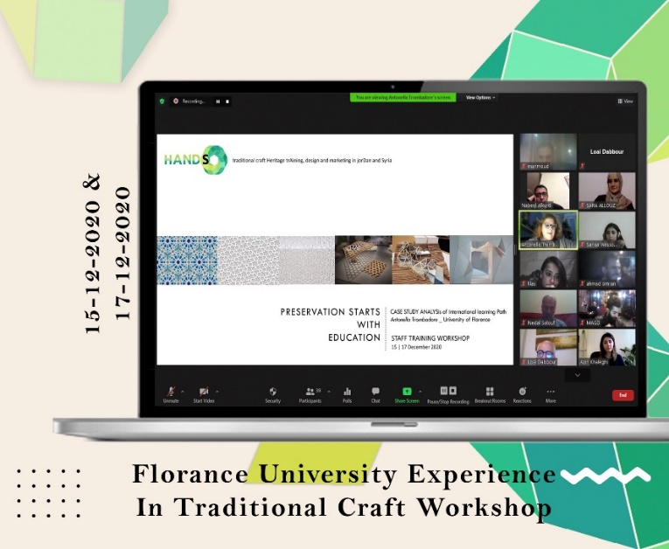
WP 5: DEVELOPMENT
Date: Saturday, 15-17/12/2020
Organizer: Florence University / Al-Zaytoonah University of Jordan
Location: Online via Zoom
As part of HANDS activities, an online staff training workshop was held to provide the project staff with an opportunity to learn from international experts about best practices and innovative approaches in traditional crafts training. The presentations illustrated best practices in traditional crafts across the Mediterranean and internationally, in addition to an interactive session on designing an innovative training path for traditional crafts.

